Curriculum Vitae

PERSONAL INFORMATION

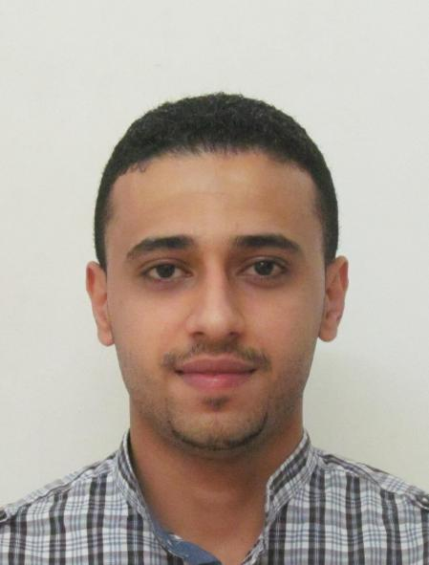

**Name:** Mutahar Ahmed Yahya Al-shami

**Nationality:** Yemeni

**Age:** 26

**Gender:** Male

**Date of Birth:** 10/NOV/1988

**Marital Status**: Single

**Mobile:** +60182313286, Malaysia

**Email:**  [mutahar_alshami@yahoo.com](mailto:mutahar_alshami@yahoo.com)

[mutashami@gmail.com](mailto:mutashami@gmail.com)

**Address:**

203 Block M8, Jalan Persiaran Pandan 7,

Pandan Jaya, Cheras, Kuala Lumpur, Malaysia.

Postcode: 55100

### OBJECTIVES:

-To find a challenging position to meet my competencies, capabilities, skills, education and experience.

-To work in a dynamic and professional environment, which will enable me to internalize, master and apply the concepts previously learnt.

-To help me grow both as an individual and a professional in the work place.

-To learn the dynamic environment of the business organization and its people.

-To get sufficient exposure to real life business practices.

-To utilize the skills and knowledge from my studies and experiences in engineering and engineering management to enhance an organization’s competitiveness

### ACADEMIC QUALIFICATION:

1. **Master Degree in Engineering Management.**

University name: University Putra Malaysia (UPM)

CGPA 3.906/4

Date: 2014 – 2016.

Location: Kuala Lumpur, Malaysia

1. **Bachelor Degree of Engineering (Hons) in Electrical and Telecommunication Engineering.**

University name: Asia Pacific University (APU)

CGPA 3.3/4

Date: 2009 – 2012.

Location: Kuala Lumpur, Malaysia

1. **Foundation of Telecommunication Engineering.**

University name: International Islamic University Malaysia (IIUM)

Date: 2007 – 2009.

Location: Kuala Lumpur, Malaysia

High School: Al-Kuwait High School.

Qualification: High School Graduation Certificate – Scientific Section

Location: Sana’a - Yemen

Grade: 91.25%

**LANGUAGES:**

|  |  |  |
| --- | --- | --- |
| **Language** | **Spoken** | **Written** |
| English | Excellent | Very Good |
| Arabic | Excellent | Very Good |
| Bahasa Melayu | Basic | Basic |

### INTERESTS:

Information Technology (experienced user of Microsoft windows and all related applications with some networking, database management, maintenance and programming experience).

Microcontrollers Embedded programming, robotics and Internet of Things (IOT).

Automotive technology and Engineering in general.

History and Theology

### SKILLS AND ABILITIES:

1. **Management skills**

* Organized and managed students programs in many societies in international Islamic University Malaysia and with others as well.
* Problem analysis/Reasoning/Creativity, use of judgment and ability to solve problems efficiently.
* Documentation and reports writing, user manual and tutorial preparation.

1. **Communication skills**

* Quick learner of new languages and social skills.
* Decision making, critical thinking, organizing and planning.
* Excellent command of English and Arabic languages.

1. **Team work**

* Member of several academic projects and associations.
* Good coordination with team members to ensure synergies are delivered within limitations

1. **Technical skills**

* Major experience and practice of programming languages and networking such as VB.net, SQL, .NET Framework, C, C#, C++, Java, and Matlab as well as working on visual Studio to design and work on windows platforms, windows mobile applications design and programming and a fair knowledge in CISCO.
* Major experience and practice of PCB designing, micro-controllers programming, embedded programming and electrical circuits designing, robotics & automation projects and application, circuit design, RF communication, I2C & USB & RS232 and other serial communications, Fair knowledge in VHDL, Semiconductors and CMOS architecture, CAD design, LabVIEW.
* Majored in satellite and wireless communication networks planning and antenna designing.
* Knowledge in Manufacturing system design and sustainable manufacturing, operation management and product development and project management.
* Knowledge in maintenance management, risk management, total quality management and industrial and occupational safety and health.
* Business Administration.
* Well-versed and experienced in office productivity computer software.
* Relatively experienced in database design, web design, and minor programming

### WORK EXPERIENCE:

* Internship: 2011 - Project Analyst Engineer (3 months), Technical Engineer (3 months) in Telekom Malaysia (TM).

Job scope:

* Analyse ongoing projects and report to the higher management and report if there are any challenges facing the project.
* Plan and manage administrative support to serve the administrative and logistic need of the operations.
* Trouble-shooting the problems reported either in the main company servers or by going to sites.
* Making the after trouble-shooting reports as a feed back to the higher management or diverting the trouble shooting to another department in some cases.
* Interpreter and translator in several occasions.

### VOLUNTEERED WORK

**Name of Organization:** Engineers Students society IIUM

**Period:** One Week

**The specific tasks discharged:** Within the faculty of engineering in IIUM, I had participated in organizing and managing the activities and programs held by the engineering faculty and I had the following tasks:

* Help the new engineering students adapting to the university.
* Distribute students in teams for the organized activities.
* Organizing the programs held by the engineering faculty.
* Got training in First-Aid.

**Name of Organization:** Alaqssah Association in International Islamic University Malaysia

**Period:** One Month

**The specific tasks discharged:** The Alaqssah Association in the university which I was studying in (International Islamic University Malaysia) arranged a program for helping people affected by the earthquakes or other disasters

and I participated as a volunteer in the following tasks:

* Inform students that the Association is collecting donations for those people affected by the earthquake.
* Collect donations from students who want to help.
* Sorting donations from clothes and other stuff then arrange and pack them.
* Deliver everything to the Association to be send to those affected by the earthquake.

### PROJECTS:

* **Development and Design of a New Flexible Multi-Station Automated Guided Vehicle System for Flexible Manufacturing System Applications.**

Project duration: September 2014 – September 2015

Description: The project proposed, developed, designed, fabricated and tested a new navigation and routing architecture to be used for Automated Guided Vehicle systems (AGV). The project included the design, fabrication and programming of the entire robotic AGV including sensors, controlling units, auxiliary units and PCBs. The project also involved a design of the interface software that is used for the remote management and monitoring of the AGV system. The proposed new dynamic flexible AGV system is based on a multi-station manufacturing environment. This AGV system will feature high flexibility in terms of future changes or modifications to the system as it is based on a universal navigational architecture in a form of a 2D grid as its tracks for navigation. Tests were carried out for both hardware and software parts of the system, and the AGV was specially designed, fabricated and optimized to best suit the new flexible 2D routing architecture. These tests were done on a designed layout consisting of sixteen workstations or destination points and one AGV parking zone.

* **Design and Simulation of a Helical Antenna for the Application of Code Division Multiple Access (CMDA) for Satellite Communication at the Frequency of 16GHZ.**

Project duration: October 2011 – October 2012

Description: The project carried out a design for the helical antenna as being best suited for the CMDA satellite application. The design was a result of lengthy calculations and alteration in physical characteristics of the antenna to best suit the required aspects of this application. The design was then made in an antenna simulation software CST (Computer simulation technology) and multiple tests and simulation runs were done to get the best simulation runs results.

* Multiple personal and freelance projects in circuits designing, embedded programming, PCB designing.
* Multiple personal and freelance projects using visual studio, vb.net and SQL designing user interface software, customer management systems, engineering related windows applications and POS.

### REFEREES:

Assoc. Prof. Dr. Tang Sai Hong

Deputy Dean (International and Mobility)

Universiti Putra Malaysia

Phone: 603-8946 4203/4204

Fax: 603-8946 4232

E-mail: [saihong@upm.edu.my](mailto:saihong@upm.edu.my)

Prof. Madya Dr Norzima bt. Zulkifli

Engineering Management Programme advisor

Phone: +603-8946 6344

E-mail: [norzima@upm.edu.my](mailto:norzima@upm.edu.my)